Perth Lanark Minor Hockey Association

REQUEST FOR REFUND

Refunds will be issued by the PLMHA for members that are wishing to withdraw from the current hockey season. There will be a $50 administration fee for all requests received prior to September 1st and a $75 administration fee after September 1st.

In addition, families must be aware that once a child takes part in any on ice sessions, then partial refunds will be given depending on the date the request is received by the Registrar or Treasurer.

No refunds will be given after December 31st and players who are expelled or suspended are not eligible for a refund.

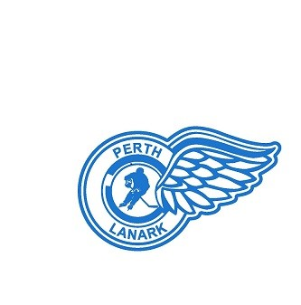**It is the responsibility of the parent to have this form completed,** and if applicable, to have the coach complete the appropriate information. **It is the responsibility of the parent to forward the completed form to** the PLMHA Registrar or Treasurer by email to: plmha.registrar@gmail.com or plmha.treasurer@gmail.com OR by mail to: PLMHA Box 441, Perth, ON K7H 3G1 Attention: Registrar or Treasurer Please Print:

Players Name:

Date:

Parents Name:

Mailing Address:

Postal Code:

Email Address:

Phone Number:

Reason for Withdrawl:

Division & Team (if applicable):

Coaches Name (if applicable):

Equipment / Jerseys Returned (if applicable):

Coaches Signature (if applicable):

____________________________________________

Parents Signature: ____________________________________________

Registrar and Treasurer use:

Date Received: Date Refund Issued:

Division VP Notified:

Refund Amount: